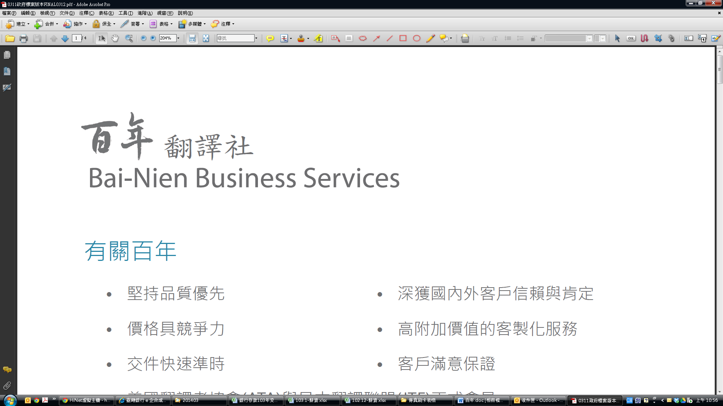 信用卡授權書
翻譯社
國際商務有限公司

Credit Card Authorization Form
客戶資料 (Client Details)
公司名稱 (Company Name)
姓氏 (Family Name) |  |  |  | 名字 (First Name)
電話 / 傳真 (Phone / Fax)
電子郵件 (E-mail)
□二聯式 □三聯式 發票  (□ Duplicate □ Triplicate Uniform Invoice) |  |  | 統一編號  (Business Administration Number)
抬頭 (Invoice Title)
發票郵寄地址
(Invoice Delivery Address)
消費內容及付款資訊 (Order & Payment Information)
消費日期(Order Placed Date) |  | 年 月 日  (Year / Month / Day)
服 務 項 目(Service Item) 報價單號碼：

金額 (Amount)：NT$
消費總額 (Total Amount) | 新台幣 拾 萬 仟 佰 拾 元整
持卡人姓名 (Name on Card)
身分證/護照號碼 (ID No./Passport No.)
發卡銀行  (Card Issuing Bank) |  |  |  |  | 國家/城市 (Country/City)
信用卡別 (Card Type) |  |  | □VISA □Master □JCB
信用卡號 (Card No.)
信用卡有效日期 (Expiration Date)
信用卡背面末三碼 (Security Code - last 3 digits on the back of your card)
簽名- 須與卡片背面一致
(Signature - must match that on the back of your card)
◆本人同意依照信用卡使用規定，一經執行訂單服務，均應按所示之全部金額，付款予發卡銀行，並同意以傳真或影印方式訂購服務，所需之影本及傳真內容具法律效用，百年翻譯社得保留接受訂單與否的權利。
I agree to pay the card issuing bank the full amount of my order once my order has been processed as per the credit card terms and conditions. I also agree to place my order by making a copy of the completed form and handing it in to Bai-Nien Business Services or by fax. The required copy of the completed form and the faxed information is legally effective. Bai-Nien Business Services reserves the right to take an order or not.

For Internal Use Only
商店代號 (Store Code) |  | 授權碼 (Authorization Code)
高雄市鼓山區博愛一路534號6樓
6F, No. 534, Bo Ai 1st Road, Gushan District, Kaohsiung City, Taiwan, R.O.C.
Tel：886-7-5581488 Fax：886-7-5577488
http://www.translator.com.tw
承辦人：葉小姐 E-mail: ac＠translator.com.tw

